1)

|  |  |  |  |
| --- | --- | --- | --- |
| Memory Device | Performance  (Disk space) | Cost  (USD) | Performance/Cost  (GB/USD) |
| Samsung 860 EVO SSD | 1 TB / 1000 GB | 149.99 | 6.67 |
| SanDisk Cruzer CZ36 Flash | 64 GB | 10.67 | 5.99 |
| SONY 100CDQ80SP  CD-R 100 Pack | 70000 MB (700 MB each) / 70 GB | 17.71 | 3.95 |
| CORSAIR Vengeance DDR4 b3200MHz RAM | 16 GB | 114.99 | 0.139 |
| WD Blue | 1 TB / 1000 GB | 49.99 | 20 |
| Maxwell 3.5 HD 10-Pack Floppy Disk | 14.4 MB (1.44 MB each) / 0.0144 GB | 21.04 | 0.000684 |
| Seagate FireCuda SSHD | 2 TB / 2000 GB | 95.99 | 20.84 |
| Toshiba External Hard Drive USB 3.0 | 2 TB / 2000 GB | 61.99 | 32.26 |
| SanDisk Ultra MicroSDXC U1 | 256 GB | 37.99 | 6.74 |
| Samsung MicroSD EVO U3 | 128 GB | 20.99 | 6.09 |

When strictly talking about storage per dollar, RAM and floppy disks performed the worst. However, this does not consider information like write or read speed.

2)

1.

|  |  |  |  |  |
| --- | --- | --- | --- | --- |
| **Qy/SR** | **00** | **01** | **10** | **11** |
| **00** | 11 | 01 | 10 | 11 |
| **01** | 11 | 01 | 10 | 01 |
| **10** | 11 | 01 | 10 | 10 |
| **11** | 11 | 01 | 10 | 00 |

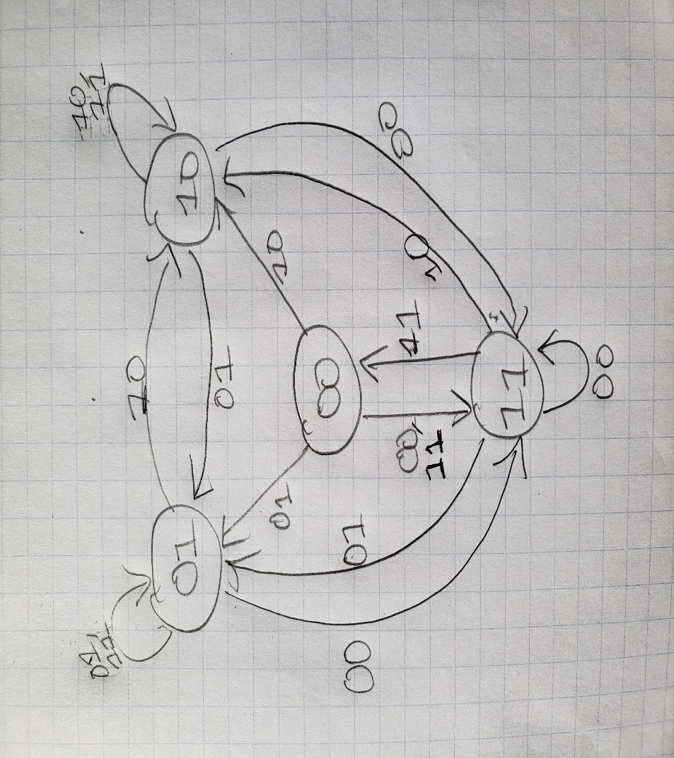

Characteristic expression:

SR = 00: (Q, y) = (1, 1)

SR = 01: (Q, y) = (0, 1)

SR = 10: (Q, y) = (1, 0)

SR = 11: (Q, y) = (0, 0), (1, 1)

State table

|  |  |  |  |  |
| --- | --- | --- | --- | --- |
| PS Q(t) \Inputs SR | 00 | 01 | 10 | 11 |
| 0 | x | 0 | 1 | 0 |
| 1 | x | 0 | 1 | 1 |

Q(t + 1) = S(t)R’(t) + S(t)Q(t)

2. If we change one NOR gate to a NAND gate, we get the following state table:

(S connects to the NOR gate and R to the NAND gate)

|  |  |  |  |  |  |  |  |  |  |
| --- | --- | --- | --- | --- | --- | --- | --- | --- | --- |
| **S** | **R** | **Qt** | **yt** | Qt | yt | Qt | yt | Qt | yt |
| **0** | **0** | **0** | **0** | 1 | 1 | 1 | 0 | 1 | 0 |
| **0** | **0** | **0** | **1** | 1 | 1 | 1 | 0 | 1 | 0 |
| **0** | **0** | **1** | **0** | 1 | 0 | 1 | 0 | 1 | 0 |
| **0** | **0** | **1** | **1** | 1 | 0 | 1 | 0 | 1 | 0 |
| **0** | **1** | **0** | **0** | 1 | 1 | 0 | 0 | 1 | 1 |
| **0** | **1** | **0** | **1** | 0 | 1 | 0 | 1 | 0 | 1 |
| **0** | **1** | **1** | **0** | 1 | 0 | 1 | 0 | 1 | 0 |
| **0** | **1** | **1** | **1** | 0 | 0 | 1 | 1 | 0 | 0 |
| **1** | **0** | **0** | **0** | 1 | 0 | 1 | 0 | 1 | 0 |
| **1** | **0** | **0** | **1** | 1 | 0 | 1 | 0 | 1 | 0 |
| **1** | **0** | **1** | **0** | 1 | 0 | 1 | 0 | 1 | 0 |
| **1** | **0** | **1** | **1** | 1 | 0 | 1 | 0 | 1 | 0 |
| **1** | **1** | **0** | **0** | 1 | 0 | 1 | 0 | 1 | 0 |
| **1** | **1** | **0** | **1** | 0 | 0 | 1 | 0 | 1 | 0 |
| **1** | **1** | **1** | **0** | 1 | 0 | 1 | 0 | 1 | 0 |
| **1** | **1** | **1** | **1** | 0 | 0 | 1 | 0 | 1 | 0 |

|  |  |  |  |  |
| --- | --- | --- | --- | --- |
| **Qy/SR** | **00** | **01** | **10** | **11** |
| **00** | 10 | 11 | 10 | 10 |
| **01** | 10 | 01 | 10 | 10 |
| **10** | 10 | 10 | 10 | 10 |
| **11** | 10 | 00 | 10 | 10 |

All our inputs result in 10 besides 0111, 0101, and 0100.

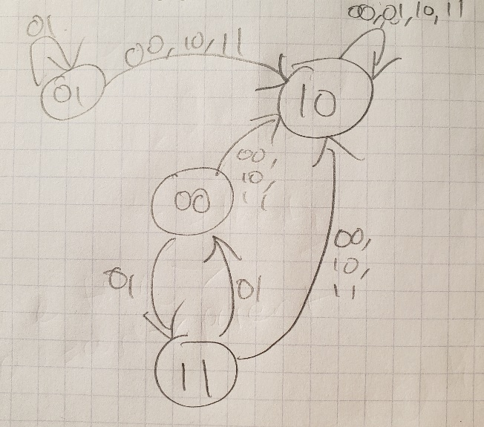

Characteristic Expression:

SR = 00: (Q, y) = (1, 0)

SR = 01: (Q, y) = (0, 0), (1, 1)

SR = 10: (Q, y) = (1, 0)

SR = 11: (Q, y) = (1, 0)

|  |  |  |  |  |
| --- | --- | --- | --- | --- |
| PS Q(t) \Inputs SR | 00 | 01 | 10 | 11 |
| 0 | 1 | 0 | 1 | X |
| 1 | 1 | 1 | 1 | X |

Q(t + 1) = Q(t) + S(t) + S’(t)R’(t)

3)

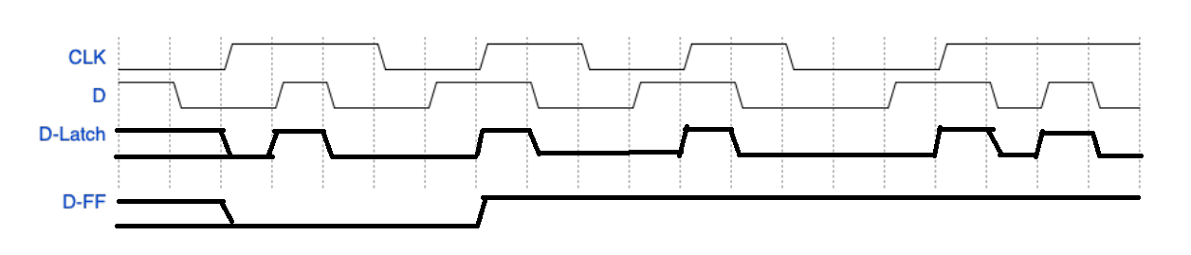

4)

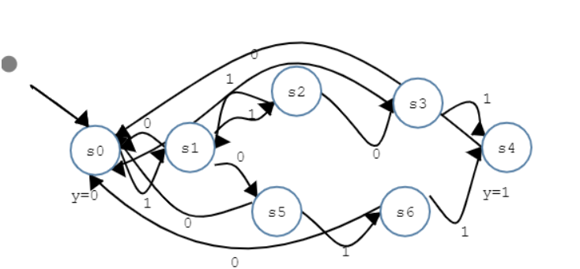

|  |  |  |
| --- | --- | --- |
| S(t) | 0 | 1 |
| S0 | S0, 0 | S1, 0 |
| S1 | S5, 0 | S2, 0 |
| S2 | S3, 0 | S1, 0 |
| S3 | S0, 0 | S4, 1 |
| S4 | S0, 0 | S0, 0 |
| S5 | S0, 0 | S6, 0 |
| S6 | S0, 0 | S4, 1 |

5)

State Table:

|  |  |  |  |  |  |  |  |
| --- | --- | --- | --- | --- | --- | --- | --- |
| Id | Q1(t) | Q0(t) | X(t) | Q1(t+1) | Q0(t+1) | D1 | D0 |
| 0 | 0 | 0 | 0 | 1 | 1 | 1 | 1 |
| 1 | 0 | 0 | 1 | 1 | 0 | 1 | 0 |
| 2 | 0 | 1 | 0 | 1 | 1 | 1 | 1 |
| 3 | 0 | 1 | 1 | 1 | 0 | 1 | 0 |
| 4 | 1 | 0 | 0 | 0 | 1 | 0 | 1 |
| 5 | 1 | 0 | 1 | 0 | 1 | 0 | 1 |
| 6 | 1 | 1 | 0 | 0 | 0 | 0 | 0 |
| 7 | 1 | 1 | 1 | 1 | 0 | 1 | 0 |

Derivation:

D1:

|  |  |  |  |  |
| --- | --- | --- | --- | --- |
| X(t)\Q1(t)Q0(t) | 00 | 01 | 11 | 10 |
| 0 | 1 | 1 | 0 | 0 |
| 1 | 1 | 1 | 1 | 0 |

D1 = Q1’(t) + Q0(t)X(t)

D0:

|  |  |  |  |  |
| --- | --- | --- | --- | --- |
| X(t)\Q1(t)Q0(t) | 00 | 01 | 11 | 10 |
| 0 | 1 | 1 | 0 | 1 |
| 1 | 0 | 0 | 0 | 1 |

D0 = Q1’(t)X’(t) + Q1(t)Q0’(t)

Logic Diagram:

